**Topics: Descriptive Statistics and Probability**

1. Look at the data given below. Plot the data, find the outliers and find out $μ, σ, σ^{2}$

|  |  |
| --- | --- |
| **Name of company** | **Measure X** |
| Allied Signal | 24.23% |
| Bankers Trust | 25.53% |
| General Mills | 25.41% |
| ITT Industries | 24.14% |
| J.P.Morgan & Co. | 29.62% |
| Lehman Brothers | 28.25% |
| Marriott | 25.81% |
| MCI | 24.39% |
| Merrill Lynch | 40.26% |
| Microsoft | 32.95% |
| Morgan Stanley | 91.36% |
| Sun Microsystems | 25.99% |
| Travelers | 39.42% |
| US Airways | 26.71% |
| Warner-Lambert | 35.00% |
|  |  |
|  |  |

Ans:

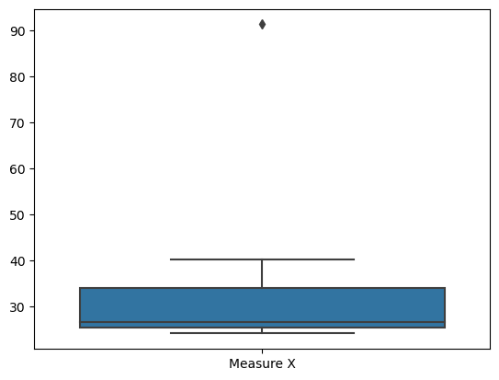

#Outlers are at max. side. Data is positively skewed as mean > median

Mean = 33.27

Median = 26.71

Std.dev = 16.94

Variance = 287.14

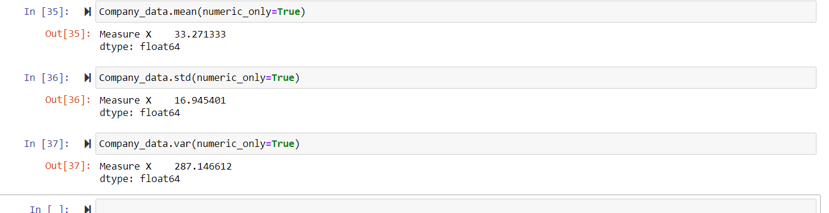



Answer the following three questions based on the box-plot above.

1. What is inter-quartile range of this dataset? (please approximate the numbers) In one line, explain what this value implies.

Ans: Q1 =5, Q3=12

IQR = 12-5 =7

It means 50% data lies in the range of 5 and 12.

1. What can we say about the skewness of this dataset?

Ans: Right (Positively)Skewed.

1. If it was found that the data point with the value 25 is actually 2.5, how would the new box-plot be affected?

Ans: The median value remains same, but the interquartile range will change, in that case there would be no Outliers.



Answer the following three questions based on the histogram above.

1. Where would the mode of this dataset lie?

Ans: Between 5 to 8 (Approx)

1. Comment on the skewness of the dataset.

Ans: Positively Skewed

1. Suppose that the above histogram and the box-plot in question 2 are plotted for the same dataset. Explain how these graphs complement each other in providing information about any dataset.

Ans: They both are positively skewed and both have outliers. The median can be easily visualized in box plot where as in histogram mode is more visible.

1. AT&T was running commercials in 1990 aimed at luring back customers who had switched to one of the other long-distance phone service providers. One such commercial shows a businessman trying to reach Phoenix and mistakenly getting Fiji, where a half-naked native on a beach responds incomprehensibly in Polynesian. When asked about this advertisement, AT&T admitted that the portrayed incident did not actually take place but added that this was an enactment of something that “could happen.” Suppose that one in 200 long-distance telephone calls is misdirected. What is the probability that at least one in five attempted telephone calls reaches the wrong number? (Assume independence of attempts.)

Ans:

Probability of getting call misdirected = 1//200

Probability of call not getting misdirected = 1-(1/200)

Number of phone call attempted = 5

Therefore, probability that atleast one in 5 attempted call reaches the wrong number is :

= 1-(199/200)^5

=0.025

1. Returns on a certain business venture, to the nearest $1,000, are known to follow the following probability distribution

|  |  |
| --- | --- |
| x | P(x) |
| -2,000 | 0.1 |
| -1,000 | 0.1 |
| 0 | 0.2 |
| 1000 | 0.2 |
| 2000 | 0.3 |
| 3000 | 0.1 |
|  |  |

1. What is the most likely monetary outcome of the business venture?

Ans: Most likely monetary outcome of the business venture is 2000.

1. Is the venture likely to be successful? Explain

Ans:  Yes, because the total earning of the venture is positive in value i.e. 800. And highest probability of earning is 2000.

1. What is the long-term average earning of business ventures of this kind? Explain

Expected Value = x * p(x)

= (-2000*0.1) + (-1000*0.1) + 0 * 0.2 + 1000*0.2 + 2000*0.3+ 3000 *0.1

= 800

1. What is the good measure of the risk involved in a venture of this kind? Compute this measure

Ans: The good measure of the risk involved in a venture of this kind depends on the Variability in the distribution. Higher Variance means more chances of risk

Var (X) = E(X^2) –(E(X))^2

= 2800000 – 800^2

= 2160000

SD = √Var  ≈ **$ 1470**

As **Variability is Quite high**  hence **Risk is high**